# Assignment 5.1a

--Download files

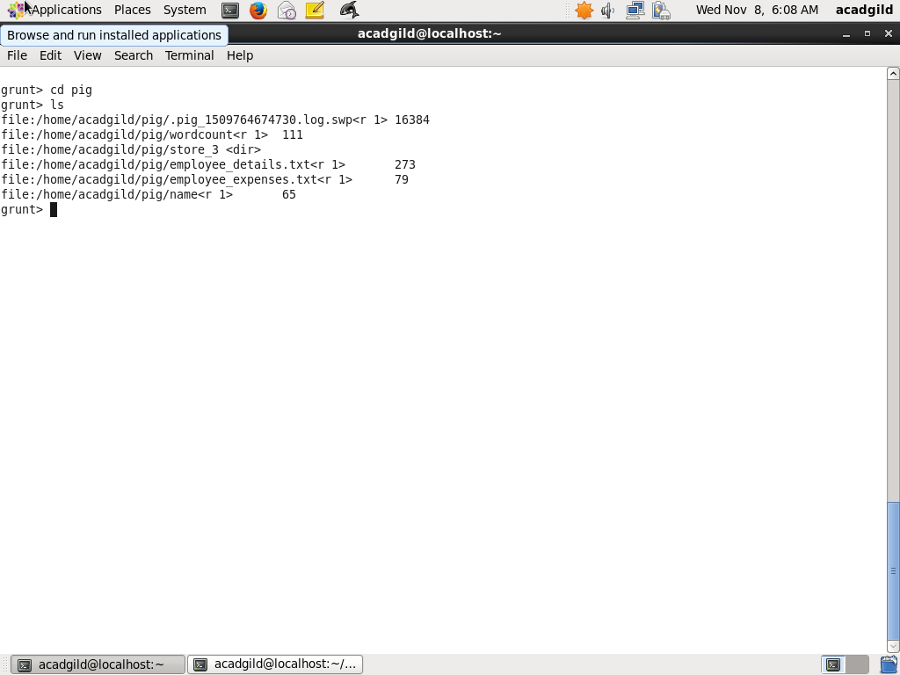

--LOAD employee_details.txt into emp_details

emp_details = LOAD 'employee_details.txt' USING PigStorage(',') AS (emp_id:int, emp_name:chararray, emp_salary:int, ram_rank:int);

-- SORT emp_details on Rank and name using ORDER

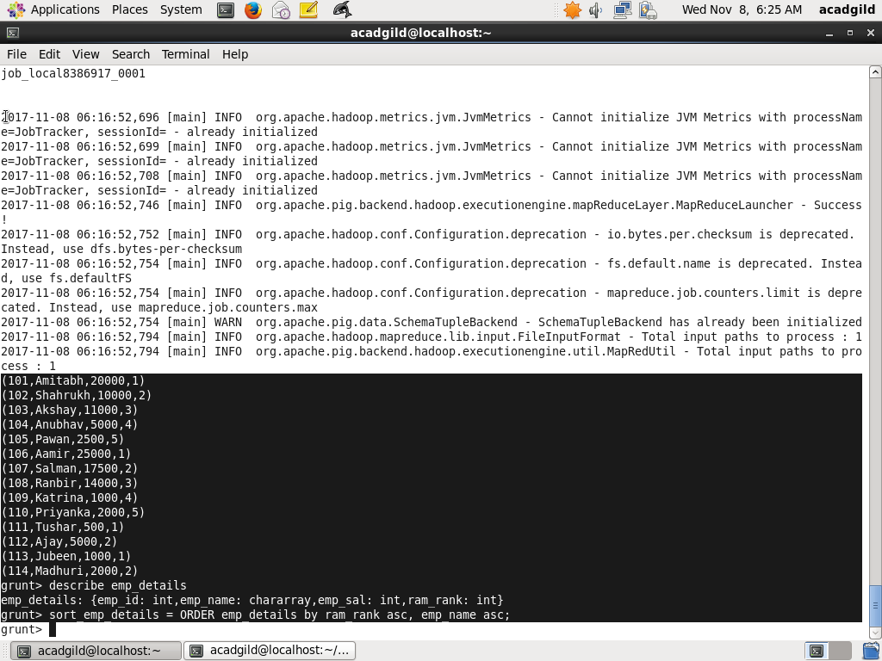

-- LIMT to top 5 and choose only name and id from each tupple

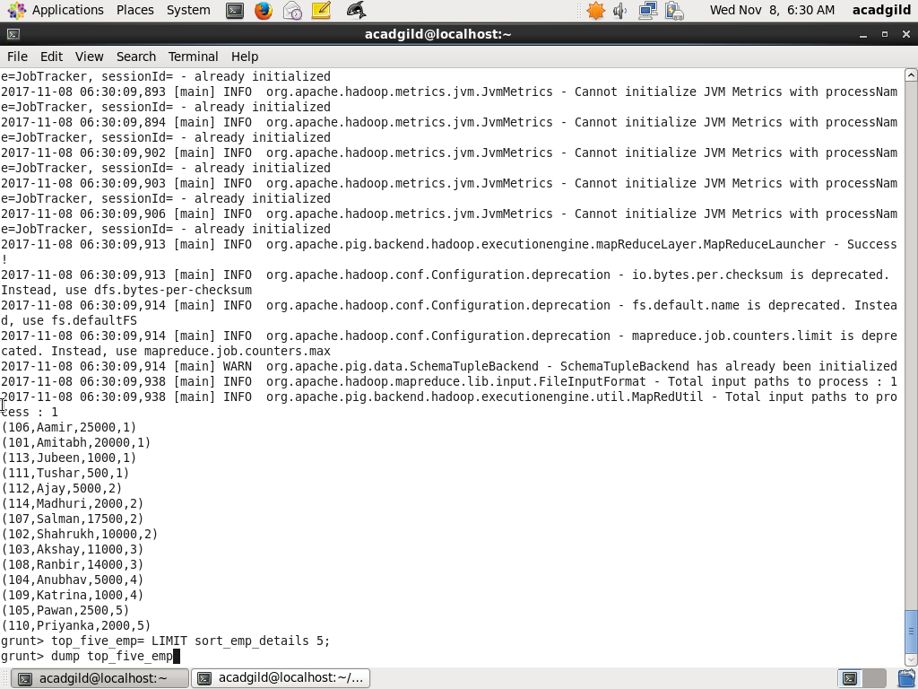

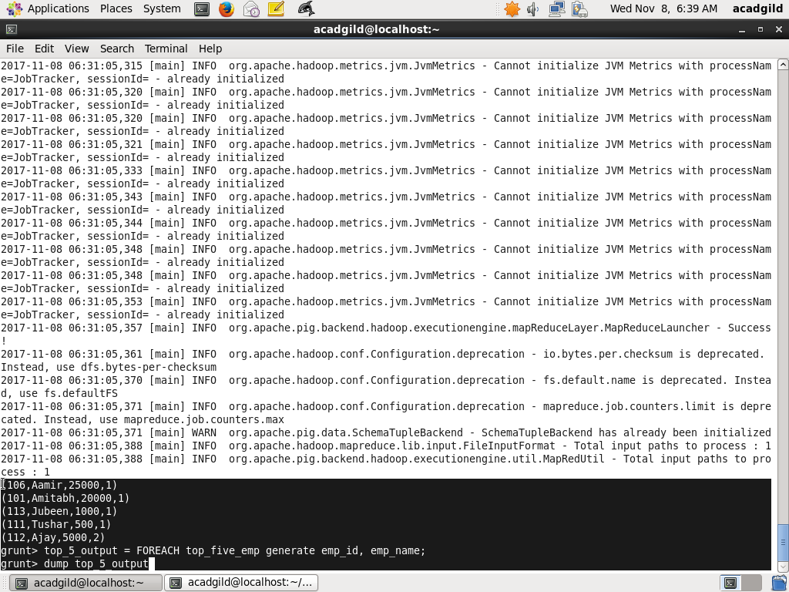

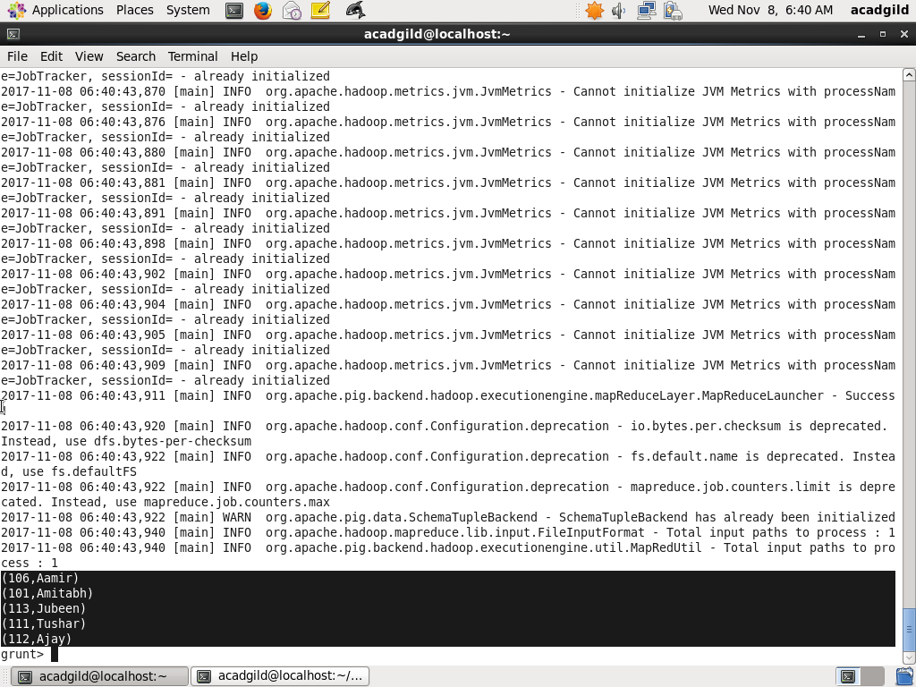

# Assignment 5.1b

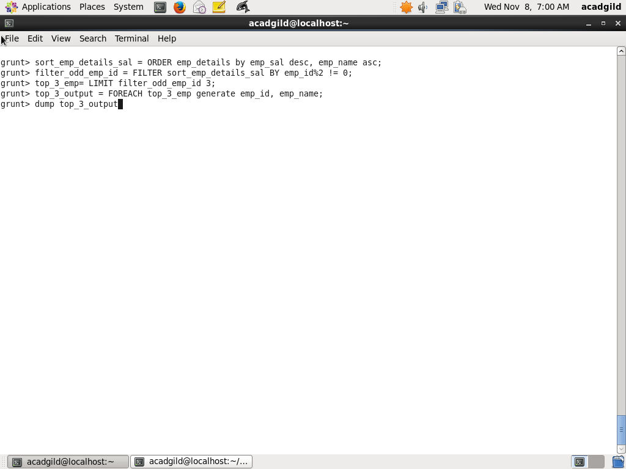

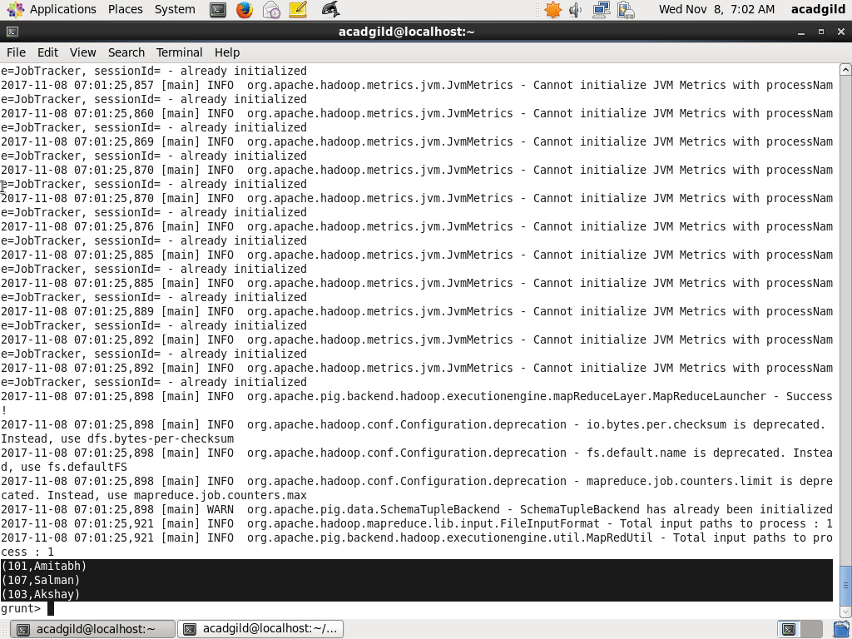

# Assignment 5.1c

-- LOAD employee expenses

emp_expenses = LOAD 'employee_expenses.txt' AS (emp_id:int, emp_expense:int);

-- JOIN expense with details on id

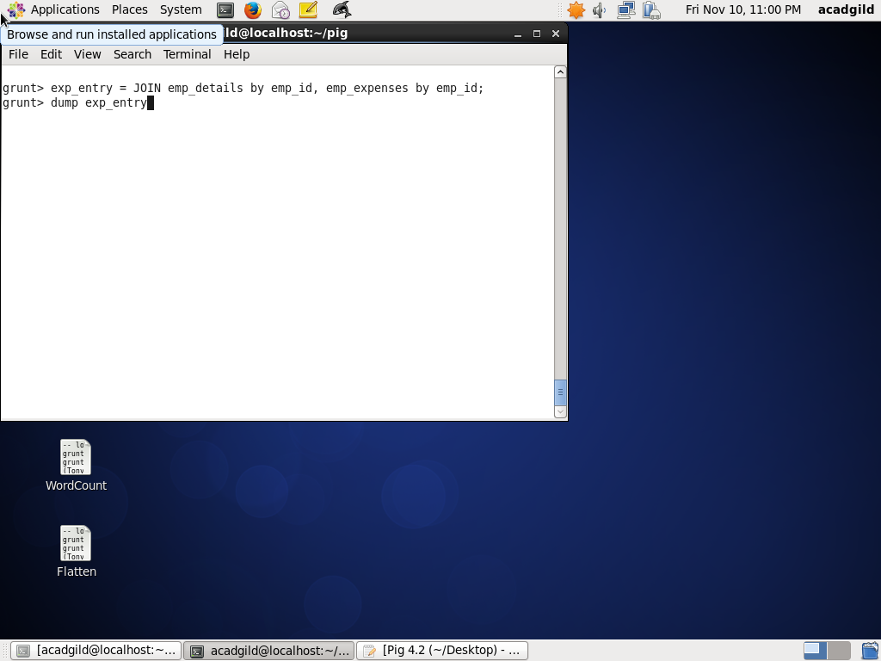

-- Get Maximum expense

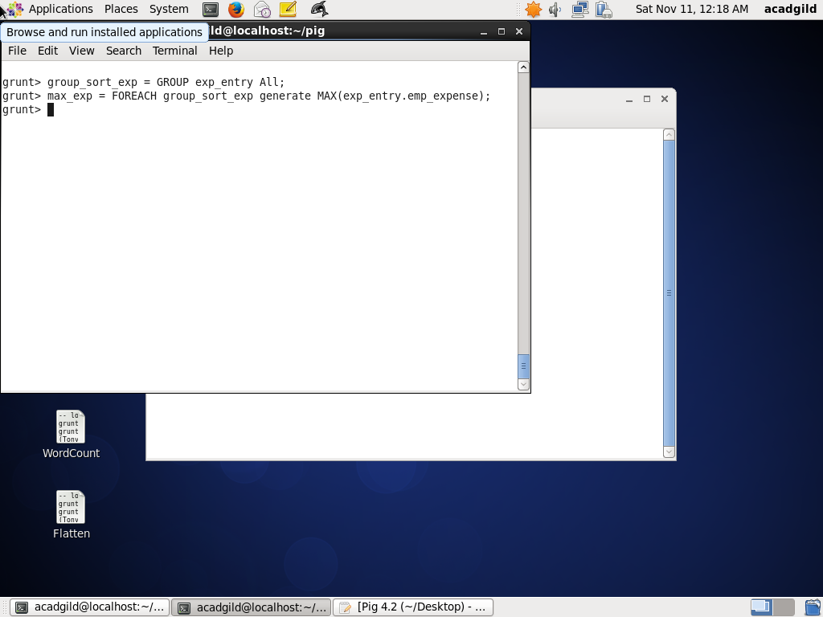

-- FILTER employees with maximum expense

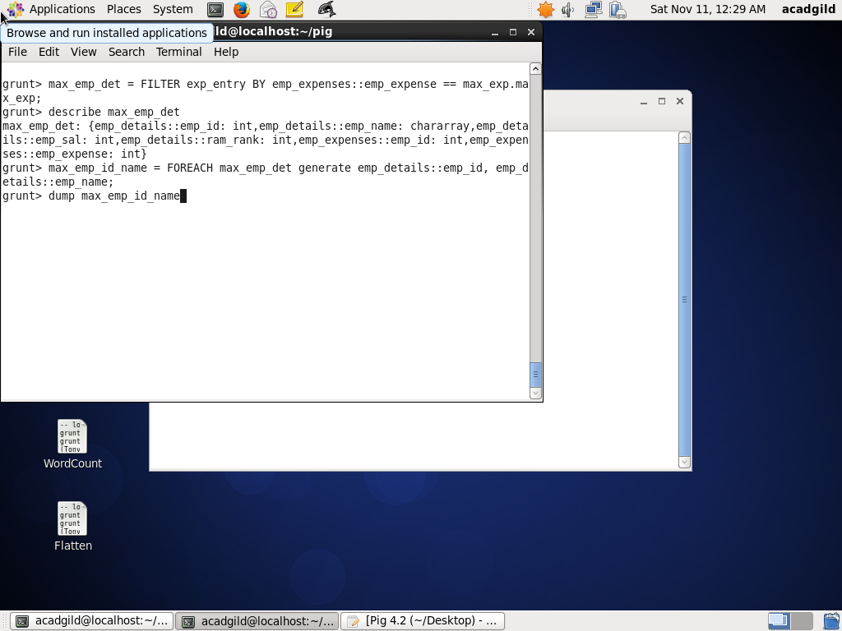

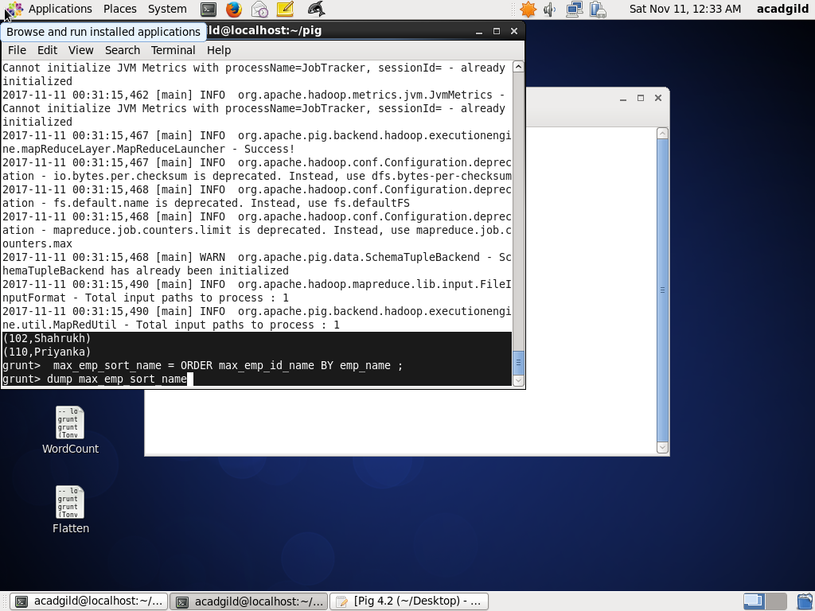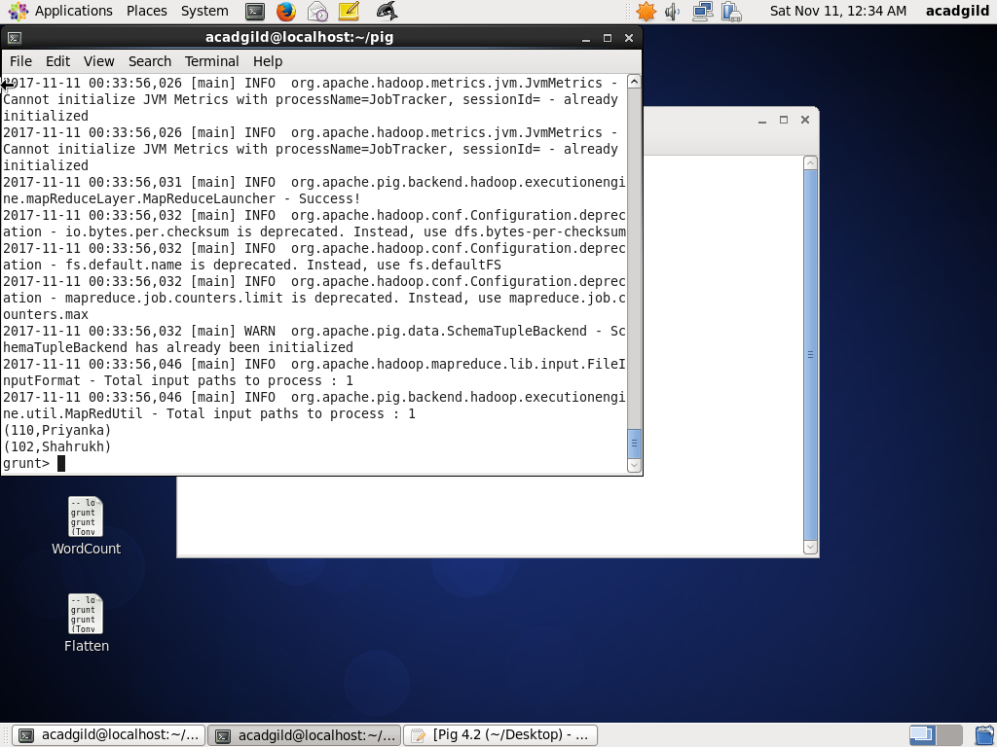

# Assignment 5.1d

-- reference id and name in a FOREACH after a JOIN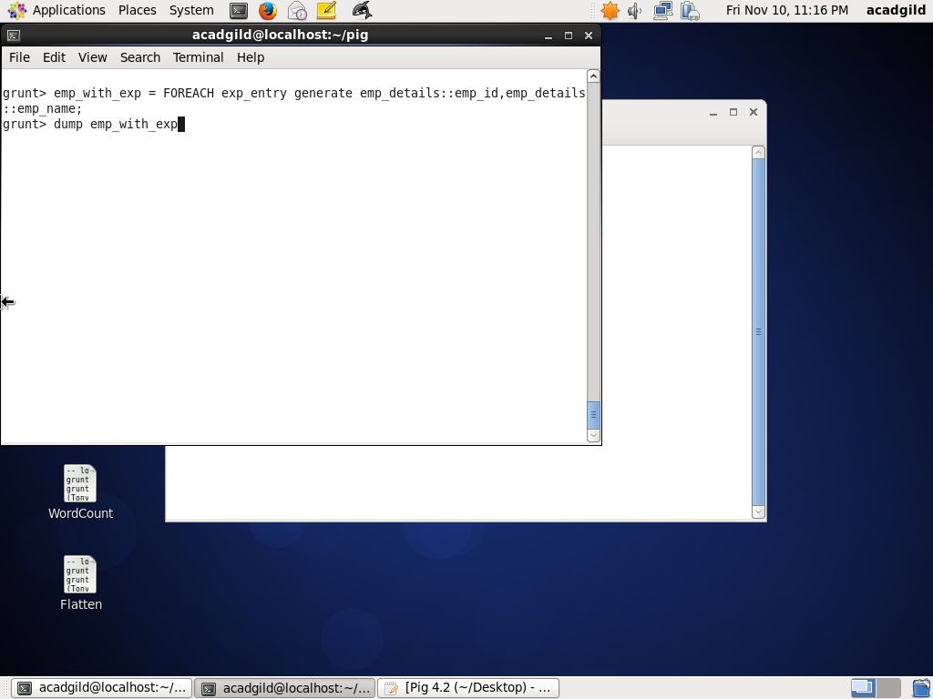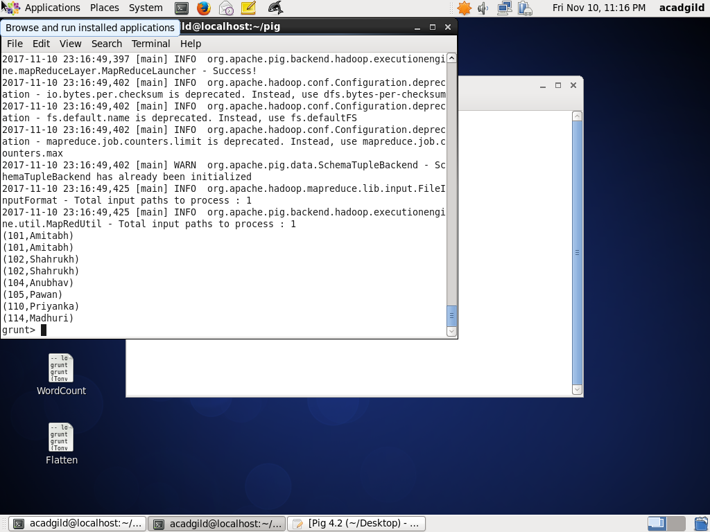

# Assignment 5.e

-- Do a LEFT OUTER JOIN between emp_details and emp_expenses

exp_entry_left = JOIN emp_details by emp_id LEFT, emp_expenses by emp_id;

-- FILTER employees with no expenses

emp_no_exp = FILTER exp_entry_left = FILTER BY emp_expenses::emp_id IS NULL;

